Jobs-To-Be-Done: A framework for writing newsletters people want to read

Nicolas Cole
May 04, 2025



Most newsletters don’t fail because of bad ideas.
They fail because the writer never stops to ask:
What job is my reader hiring this newsletter to do?
So today, I’m going to show you how to use Jobs-To-Be-Done to make your newsletter something people need—so you can effortlessly pull them into your ecosystem.
Here's what we'll cover:
- The Harvard study that flipped market research on its head—and why applying it to your newsletter makes it a 10x more addictive read
- The real reason your audience opens (or ignores) your emails—and how to write directly to the job they’re hiring you to do
- A 5-part prompt sequence that reveals why people subscribe, ghost you, or never even consider your content in the first place
Let's dive in!
The Jobs-To-Be-Done Framework

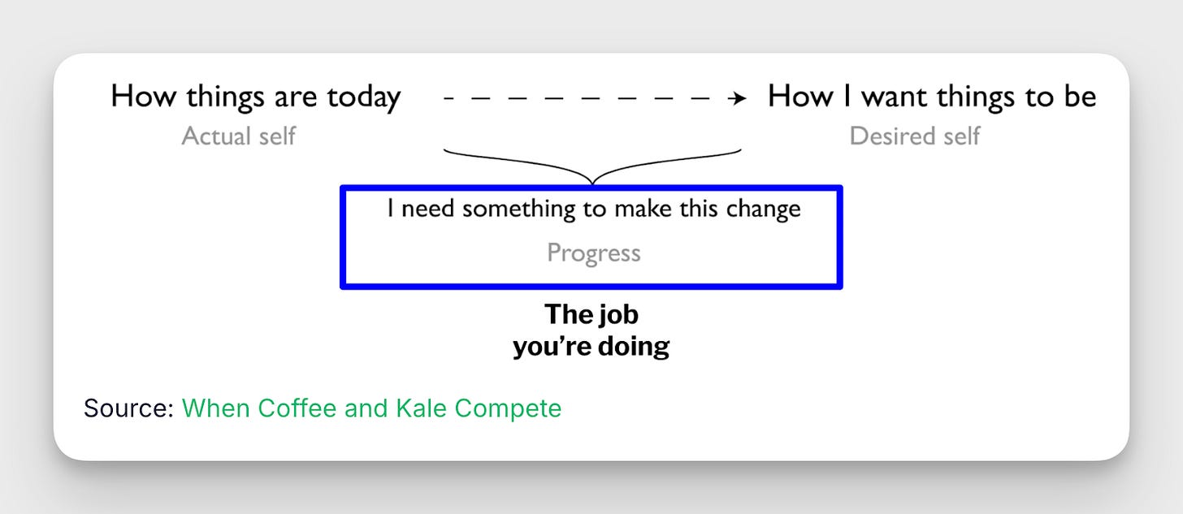

A “Job-To-Be-Done” has three parts:
When [situation], I want to [action], so I can [outcome].
- The "when" is the situation your reader is in.
- The "want" is what they’re trying to do.
- The "so I can" is the result they care about.
If you want to write content to help your reader, you need to understand both their situation and their goal.
Here’s a classic example from the creators of this framework:
A restaurant chain wanted to sell more milkshakes. So, they improved the flavors. They made them creamier. But nothing changed. Then they noticed a lot of people were buying milkshakes early in the morning—and drinking them alone in their cars.
They realized the milkshake wasn’t a treat.
It was a solution to a boring commute.
Once the chain understood this, they changed their product. They made the milkshake thicker (so it lasted longer) and added fruit chunks (to make it more engaging). Then they marketed it as a smart breakfast-on-the-go.
And sales finally went up.
You can listen to the talk from Harvard Professor and legendary innovator Clayton Christensen here:
Your newsletter has a “job to be done.”
People “hire” your newsletter because they want to DO something.
You don't hire Netflix because you want a streaming service. You hire Netflix because you want to be entertained, relax after work, or have something to talk about with friends. The same is true for your newsletter.
Think about your email inbox.
The newsletters you open week after week are the ones that help you:
- Make more money
- Save time on work
- Learn something specific
- Look smarter in meetings
- Get ahead of your competition
These are "jobs" you readers need done.
When you know the real job your newsletter is doing, your content gets way more useful—and 10X more valuable to your reader.
Here's how to uncover those jobs (and find a never-ending supply of high-value topics for your newsletter).
Let’s break it down.
Step 1: Identify the situations (WHEN) your audience faces.
First, we need to understand what context your readers find themselves in.
For example:
- When presenting campaign results to executives...
- When their team misses a deadline...
- When competitors launch a new campaign...
- When budget season approaches...
Here's a prompt to help you uncover these situations:
I write for {your audience}.

What specific situations do they regularly find themselves in?

List 10 specific contexts where they might need help.

Each situation should complete: "When [specific context]..."

Focus on situational context (not emotions, not tasks).

Think Jobs-To-Be-Done—real-world settings, environments, or triggers that set up a job.

Keep it short, specific, and grounded in daily life.

Return only the situational trigger, nothing after.
Add your target audience in the prompt above and you’ll be off to the races.
Step 2: Define their motivations (I WANT TO) in each situation.
Now, let's understand what your readers want to accomplish in these situations.
- I want to show ROI...
- I want to defend budget...
- I want to highlight wins...
- I want to prepare responses.
Use this prompt:
For this situation: "When [situation you identified]"

What specific activities do they want to do?

List 7 actions that complete: "I want to [activity]..."

Think Jobs-To-Be-Done.

Use 3 words or less for each activity.

No quality judgments (e.g compelling).
Step 3: Clarify the outcomes (SO I CAN) they desire.
Finally, let's identify what success looks like to your readers.
- ...so I can secure next year's funding
- ...so I can justify my team's work
- ...so I can prove marketing ROI
- ...so I can protect my department's resources
Try this prompt:
For this job: "When [situation], I want to [activity]"

What are they hoping to achieve?

List 5 desired outcomes that complete: "so I can..."

Focus on specific, measurable results.
You should have a list that looks something like this after this step.

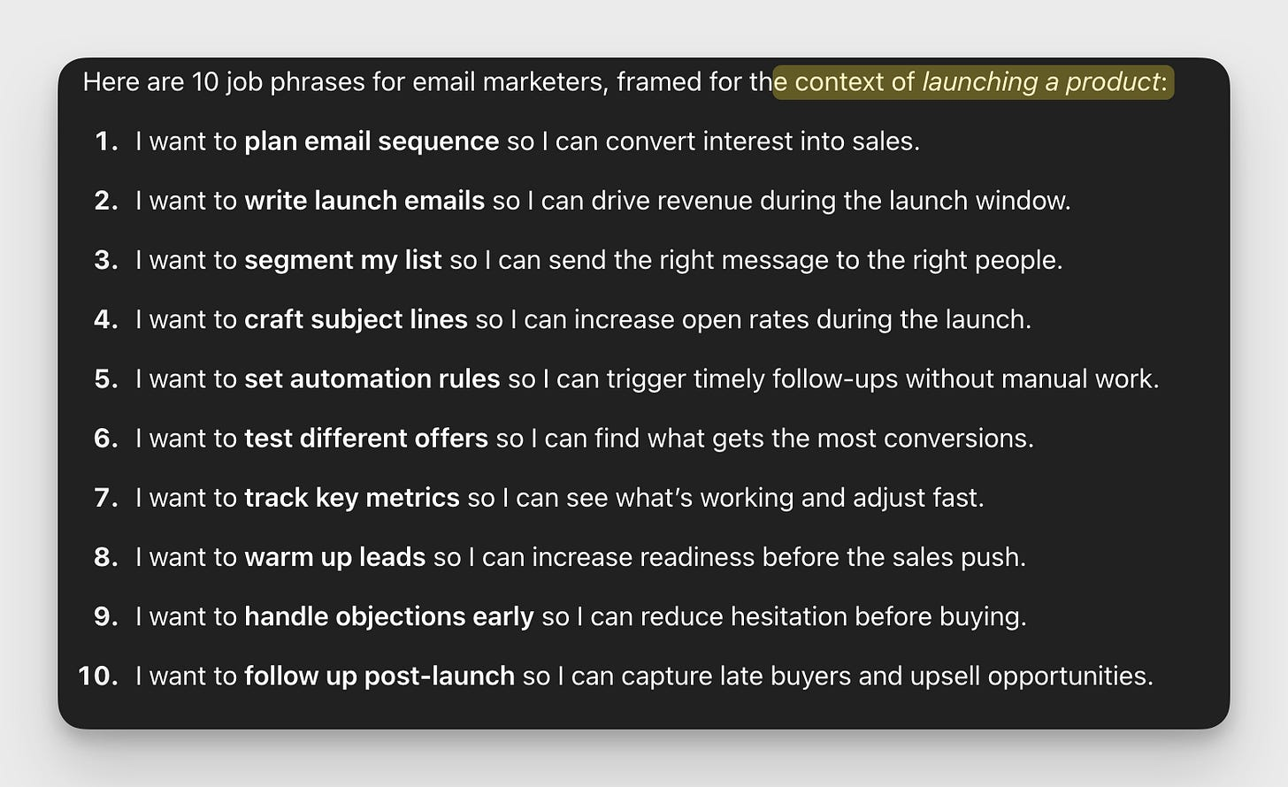

Boom—you just uncovered tons of jobs your newsletter can help get done.
Step 4: Turn each job into a newsletter topic.
Now here's the fun part.
Each job becomes a topic your readers will devour.
Take "I want to write daily emails so I can stay top of mind":
- You could write: "The 15-Minute Email Writing System That Sells"
- Or: "7 Daily Email Templates Guaranteed To 2X Your Revenue"
- Or: "How To Add 6-Figures To Your Bottom Line Sending 1 Email Per Day"
See how one job creates multiple newsletter topics?
Here's a prompt that does the heavy lifting for you:
I have this reader job:

"When [situation] I want to [activity] so I can [desired outcome]."

Create 5 newsletter topic headlines that would help someone succeed at this job.

For each headline, include:
- A specific promise
- A number or timeframe
- An expected outcome

Format as: "[Number] ways to [solution] to [desired outcome]"
Step 5: Go even deeper with a complete Jobs-To-Be-Done Needs Analysis.

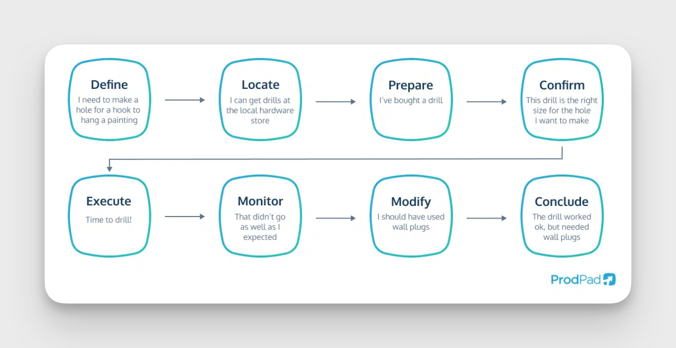

Once you've identified a core job statement, you can go even deeper by breaking it down step-by-step by doing a “needs analysis.”
A Jobs-To-Be-Done Needs Analysis is a way of breaking down everything involved in completing a task (or "job") that someone wants to do. It's like creating a detailed map of their journey from start to finish. This reminds me of Alex Hormozi's approach to defining a dream outcome and identifying every possible problem someone might encounter. But instead of focusing on the 4 factors of value, we'll use the Jobs-To-Be-Done framework.
Here's what it includes:
1. Job Steps: This breaks down the main task into a sequence of smaller steps.
For example, if the job is "play a new video game," the steps might be:
- Find information about the game
- Get the game (download or purchase)
- Install the game
- Learn the controls
- Play the first level
- Get better at the game
- Complete the game
2. Barriers at Each Step: For each step, we identify what might make it difficult.
For "Learn the controls":
- Too complicated (Effort barrier)
- Takes too long to memorize (Time barrier)
- Controls feel awkward for your hands (Achievement barrier)
- Doesn't feel worth the time investment (Outcome barrier)
3. Emotional Jobs: These are the feelings people want to experience.
- Feel excited when starting the game
- Feel a sense of mastery when improving
- Feel accomplished when winning
- Feel part of a community when discussing with friends
4. Related Jobs: These are connected tasks that often go along with the main job.
- Finding people to play with
- Comparing scores or achievements with friends
- Figuring out when to fit gaming into your schedule
This helps you write about very specific parts of your readers' experiences, which helps you to create content specifically about the hardest steps, the biggest barriers, the emotional rewards they're seeking, or related challenges they face.
It's like being able to read your readers' minds about exactly what they're struggling with and what they really want to achieve.
Here’s the prompt:
Now, given this Core Functional Job:

{INSERT YOUR [ When _____ ] [ I want to _____ ] [ so I can _____ ] Statement}

I want you to create a Jobs-To-Be Done Needs Analysis:

Include:

1. A Core Functional Job Breakdown by job step:
define, locate, prepare, confirm, execute, monitor, modify, conclude
With list of 4 barriers for each step: Effort (too hard), Time (takes too long), Likelihood Of Achievement (won't work for me), Outcome (not worth it)
Explain the steps (in detail) requited to complete each step.
2. Emotional Jobs
3. Related Jobs
Output Format
# [Job]: [Core Functional Job Name]
## [Num]. [Job Step Name]: [Step]
Job Step Step-By-Step Explanation
- Barriers List
...

## Emotional Jobs
- Emotional Job List
## Related Jobs
- Related Job List
Add any “When-Want-So” job statement from steps 1-4 into the prompt above and ChatGPT will break it down for you.
This breakdown gives you a gold mine of newsletter topic ideas by revealing:
- The specific steps your readers take to complete their job
- The barriers that stop them at each step
- The emotional needs they're trying to meet
- Related jobs that might also need solving
For example, if your core job is "When planning my content calendar, I want to generate topic ideas so I can meet my publishing deadlines," this analysis will break down each step of that process and show you exactly where your readers struggle.

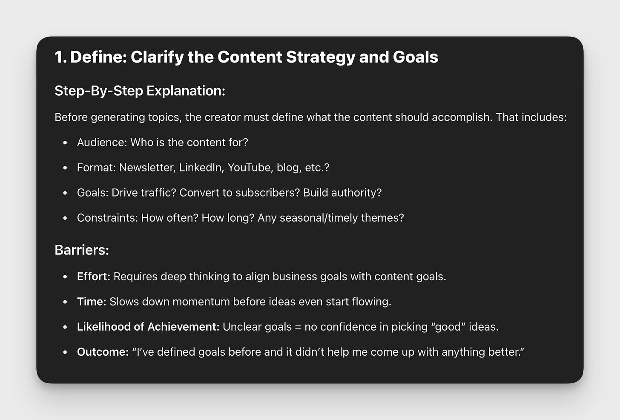

Now you can create segmented newsletter content that addresses even more specific pain points.
Do this for your top 3 reader jobs and you'll have enough targeted content ideas to last you a year.
[Bonus]: Want to know what jobs matter most to your reader before you start writing?
Here's the easiest way to validate your newsletter topics:
Survey your audience.
Just ask: "What are you trying to accomplish in the next 90 days?"
Then sort their responses into job categories and then use the prompt in Step 5 to break each job down further.
The jobs mentioned most often? Those are your most valuable newsletter topics.
Tip: The language they use to describe their jobs becomes your exact headline language. Because nothing resonates more than speaking directly to the job someone's trying to get done.
Don’t have any readers yet?
No problem.
You can use AI to conduct a job interview!
Unlike a traditional interview that focus on demographics, a jobs interview digs into the specific situations, motivations, and desired outcomes that cause someone to "hire" a product or service (in this case, your newsletter).

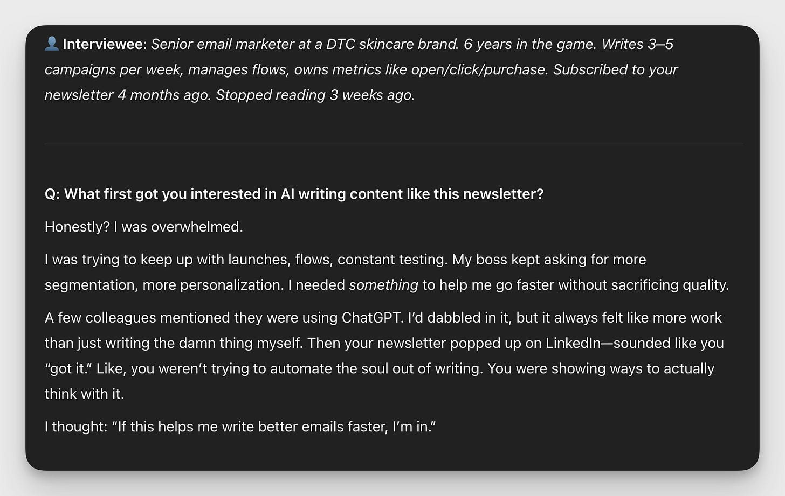

Here’s how:
In the script below, fill in your newsletter topic and target audience, and choose one of the three options (recently interested, recently lost interest, never heard of your topic). Talking to all three helps you understand why people start reading newsletters like yours, why they might stop, and how to reach people who don't know they need your help yet.
Run the prompt 3-5 times for each audience segment and look for common themes.
Here’s the prompt:
I am writing a newsletter about {topic}.

It's for {target audience}.

I want you conduct a Jobs-To-Be-Done interview with my target audience.

I want you to focus on someone who {CHOOSE ONE: is recently interested, recently lost interest in, or has never heard of} my newsletter topic.

The goal is to understand:

- Why people get interested
- Why people lose interest
- What people who aren't familiar with the topic are trying to accomplish (and how they're currently doing that)
- What pushes/pulls people into follow me (or someone else)

Answer as the target.
Here's what this looks like in action:
One of our Ship 30 writers used this framework to grow from 0 to 500 subscribers in just 3 months.
His secret?
He identified that his audience (marketing managers) had these 3 core jobs to be done:
- Impress executives
- Prove campaign ROI
- Get budget approved
Every newsletter he wrote helped get one of these jobs done.
And his open rates stayed above 50% the entire time.
That's the power of Jobs-To-Be-Done for your newsletter.
Now you understand why some newsletters thrive and others die.
The difference isn't talent.
Or writing experience.
Or even how often you publish.
It's whether you're helping your readers get their jobs done.
So before you write your next newsletter, ask yourself:
What jobs are my readers actually trying to complete?
Answer that question, and you'll never worry about open rates again.
Chat soon,
—Dickie & Cole

